Microscope Practical

Part A: Preparing a Microscope Slide

Prepare a wet mount section of an onion skin and stain it with iodine or methylene blue.

Examine your slide under the microscope at low (40x) and then medium (100x) magnification.

Draw what you can see in the space provided. Label appropriately.

Part B: Estimating the size of an object

Remove the slide from the microscope and then examine a mini-grid slide.

1. Using the mini-grid determine the field of view (diameter) at 40x and 100x magnification.

|  |  |  |  |
| --- | --- | --- | --- |
| Field of view at 40x |  | Field of view at 100x |  |

1. Now that you have worked out the field of view, you can estimate the length of the onion cells. Remove the mini-grid and replace your stained onion cells under the microscope. Count how many cells, end on end, would make a line across the diameter of the field of view. Divide the size of the field of view by the number of cells.

|  |  |
| --- | --- |
| Approximate length of an onion cell |  |

1. Take a hair from your head and examine it under the 400x magnification. Estimate the diameter of the hair. To do this you will need to determine the field of view at 400x magnification.

|  |  |
| --- | --- |
| Field of view at 400x |  |
| Diameter of a human hair |  |

Part C: The Microscope

Label the diagram of the microscope.



Part D: Calculations

1. Complete the following statements.
2. As the magnification of a microscope increases the field of view _____________.
3. To change ‘mm’ to ‘micrometres’ multiply by ______________.
4. If the magnification of a microscope is increased four times, the field of view will ______________ by four.
5. If the magnification of a microscope is halved, the field of view will ______________ by _____________ times.
6. A microscope has a 5x eyepiece, a 15x objective lens and a 35x objective lens. What are the lowest and highest power magnifications for this microscope?
7. What are the benefits of using low power magnification?
8. Describe the benefits of high power magnification.
9. Two animals (S & T) are observed under a microscope with the following lens combinations:

|  |  |  |
| --- | --- | --- |
| Animal | Eye piece | Objective |
| S | 5 | 10 |
| T | 10 | 50 |

Both animals fill the field of view. Which animal is larger?

1. A scientist prepared a wet mount of some microscopic organisms. An image of one of the organisms is shown below. The units on the scale bar are in millimetres.



1. What is the diameter of the field of view?
2. Give the dimensions of the organism (length and width) in millimetres.
3. The organism uses the cilia on its surface to move. Estimate the average length of the cilia in micrometres.
4. At a magnification of 150x a microscope has a field of view of 0.8 mm. What would be the diameter of the field of view at a magnification of 300x? Give your answer in micrometres.
5. A biologist examines a sample of blood under a microscope. She estimates that about 16 red blood cells would fit across the field of view if they were placed end to end in a straight line. If the field of view is 0.2 mm across, what is the approximate diameter of a red blood cell? Give your answer in micrometres.
6. If the biologist in Question 8 changed the objective lens so that the magnification was halved, how many red blood cells would fit across the new field of view?
7. A microscope has a field of view of 3.2 mm at 40x magnification.
8. What would be the field of view at a magnification of 400x? Give your answer in micrometres.
9. Explain the reasoning behind your answer.

**Investigation Euglena**

Part A: Viewing Euglena

Prepare a slide with live Euglena.

View the slide under 40x and then 100x magnification. Sketch a diagram of a Euglena in the space below.

1. What type of living thing is a Euglena? (Choose from animal, plant, fungus, protist or bacterium)
2. How do Euglena propel themselves through fluid?
3. Euglena are green in colour. What type of chemical process are they likely to carry out?
4. Using the 10x objective lens, pick a field and then estimate the number of Euglena in the field. Repeat this five times and then calculate an average.

|  |  |
| --- | --- |
| Estimate 1 |  |
| Estimate 1 |  |
| Estimate 1 |  |
| Estimate 1 |  |
| Estimate 1 |  |
| Average |  |

1. If the field of view at 100x magnification is 2.2 mm, calculate the average density of Euglena per square millimetre.

|  |  |
| --- | --- |
| Density of Euglena |  |

1. Add a drop of vinegar to the slide. What effect does this have on the Euglena?

Part B: Calculations

1. Below is an image of several Euglena taken with a light microscope. The magnification of this image is 7,000 times. Calculate the average length of a Euglena, excluding the flagellum. To calculate this you should take average length of five Euglena.

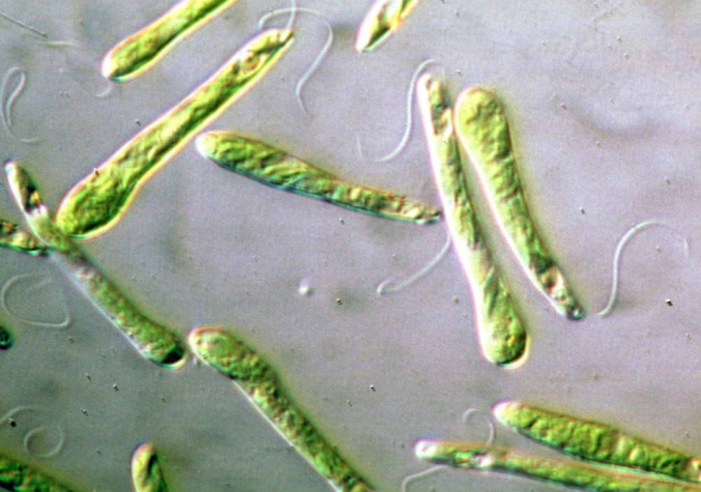

1. The image below was taken with an electron microscope. The magnification of the image is 19,500x. Based on this information determine the average length of the head piece of a sperm. To calculate this you should take the average of at least five sperm.

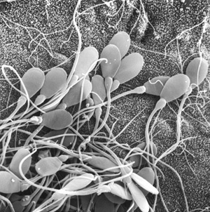

1. Below are three images of an organism with a long, whip-like tail.



1. Which image has the lowest magnification?
2. Which of the above images would have the brightest field of view? Explain your choice.
3. The length of the organism is approximately 1.3 millimetres. Estimate the size of the field of view in I. Give your answer in millimetres.
4. Estimate the size of the field of view in II. Give your answer in micrometres?
5. If the magnification of the microscope for image I is 20x, what is the magnification for image II?